Exercise: RestFul Web Service Part 1

1. Create a simple REST ful service in Spring Boot which returns the Response "Welcome to spring boot".

Answer:

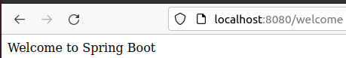

1. Create an Employee Bean(id, name, age) and service to perform different operations related to employee.

Answer:

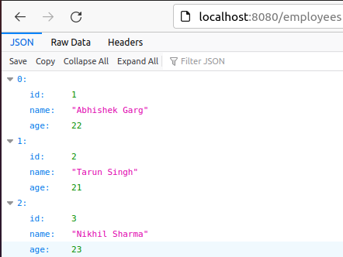

1. Implement GET http request for Employee to get list of employees.

Answer:



1. Implement GET http request using path variable top get one employee

Answer:

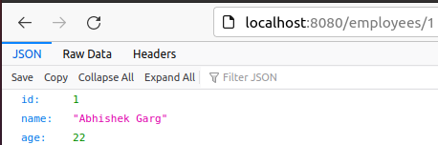

1. Implement POST http request for Employee to create a new employee.

Answer:

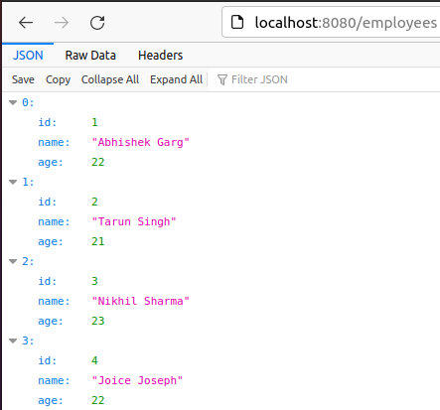

1. Implement Exception Handling for resource not found

Answer:

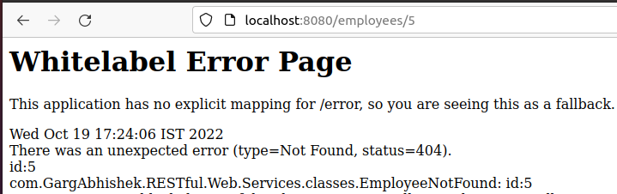

1. Implement DELETE http request for Employee to delete employee

Answer:

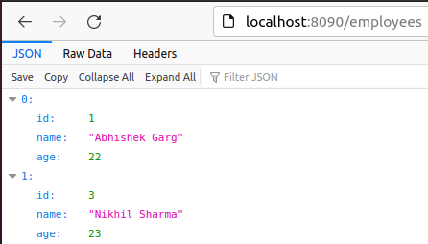

1. Implement PUT http request for Employee to update employee

Answer:

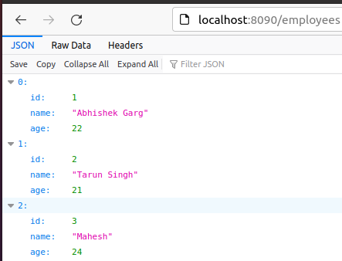

1. Apply validation while create a new employee using POST http Request.

Answer:

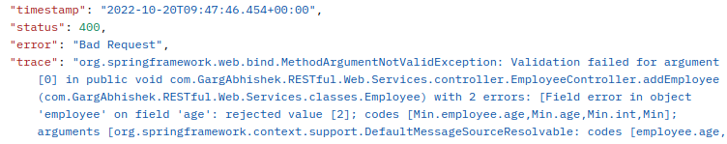

1. Configure actuator in your project to check the health of application and get the information about various beans configured in your application

Answer:

